**Overlay ActivityIndicator / Progress Bar / Loading Spinner in React Native**

This is an Example of Overlay ActivityIndicator / Progress Bar / Loading Spinner in React Native. This is the most common thing that we use in every application. We will use the react-native-loading-spinner-overlay library to make an overlay Loader. This is basically used to block the screen while the application is doing some work like fetching data from the server or processing any big data which needs some resources.

To make an Overlay ActivityIndicator we will use Spinner component provided by react-native-loading-spinner-overlay.

Run the following command

**npm install react-native-loading-spinner-overlay –save**

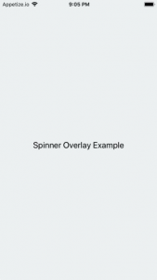 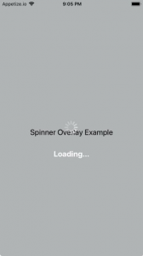

/*Example of Recat Native Loading Spinner Overlay*/

import * as React from 'react';

import { Text, View, StyleSheet, Button } from 'react-native';

import Spinner from 'react-native-loading-spinner-overlay';

export default class App extends React.Component {

  constructor() {

    super()

    this.state = {

      //default loading false

      loading: false,

    };

  }

  componentDidMount() {

    //Setting a timer to show the spinner demo in every 3 second

    setInterval(() => {

      this.setState({

        //change the state of the laoding in every 3 second

        loading: !this.state.loading,

      });

    }, 3000);

  }

  render() {

    return (

      <View style={styles.container}>

        <Spinner

          //visibility of Overlay Loading Spinner

          visible={this.state.loading}

          //Text with the Spinner

          textContent={'Loading...'}

          //Text style of the Spinner Text

          textStyle={styles.spinnerTextStyle}

        />

        <Text style={{ textAlign: 'center', fontSize: 20 }}>

          Spinner Overlay Example

        </Text>

      </View>

    );

  }

}

const styles = StyleSheet.create({

  container: {

    flex: 1,

    justifyContent: 'center',

    textAlign: 'center',

    paddingTop: 30,

    backgroundColor: '#ecf0f1',

    padding: 8,

  },

  spinnerTextStyle: {

    color: '#FFF',

  },

});